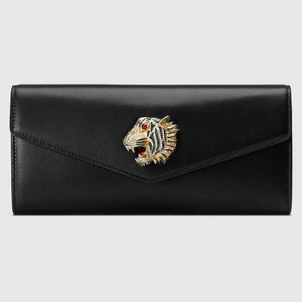

Broadway leather clutch with

Tiger

PRODUCT DETAILS

**An evening clutch made from smooth black leather is decorated with an enameled**

**crystal-encrusted tiger head. The emblem, inspired by a vintage piece from legendary**

**fashion and jewelry designer Hattie Carnegie's 1940s archives, defines this bag,**

**contrasting against its sleek construction.**